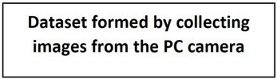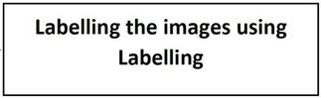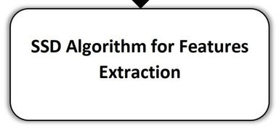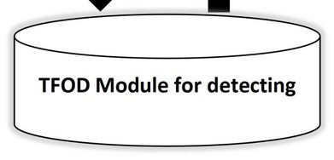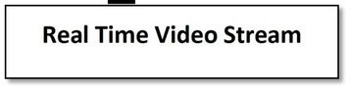

Solution Architecture

|  |  |
| --- | --- |
| **Team ID** | **PNT2022TMID24798** |
| Project Name | **Real-Time Communication System Powered by AI for specially Abled** |